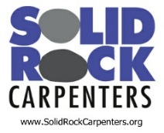 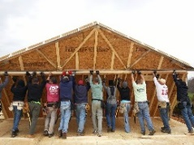 

**Serving Appalachia Service Project  
Saturday, September 24, 2016**

[**Solid Rock Carpenters (SRC)**](http://www.solidrockcarpenters.org/) **is happy** **to announce an upcoming 'Framing Day" event in Park Ridge, IL on Saturday, September 24th.  *Building Homes and Bringing Hope* to families in need has been the mission of Solid Rock Carpenters since 2005. At the Framing Day, SRC volunteers will be building wall sections of homes that will be shipped to** [**Appalachia Service Projects (ASP)**](http://www.asphome.org/) **ready for assembly by volunteer groups later in the year (SRC Trips - Nov 7-11, 2016 and Jan 2-6, 2017).**   
  
**About** [**Appalachia Service Project -   ASP**](http://www.asphome.org/) **is a well-established ministry working to provide “warmer, safer, drier” housing for the impoverished in the Central Appalachia Region since 1969. Since 2014, over 200 SRC volunteers have traveled to Tennessee, working with ASP on the building of multiple homes.  During these trips SRC participants have been quite moved by the complex needs of the people it has served and is committed to assisting in building awareness of these needs, as well as, building additional homes this year.**  
 **Everyone is welcome participate - No experience necessary!  In addition to volunteering for the build, there will be many ways to contribute. Information and registration:** <http://www.surveygizmo.com/s3/2881493/SRC-ASP-Framing-Day>  
**Cost - The main goal of this outreach event is to support the ministry of ASP. Although there is no cost to volunteering for the Framing Day Event, donations of any amount are encouraged for each participant.    
* Opportunities for making donations will be available at each work site.   
** ASP is extremely grateful to all of its donors and looks forward to sharing the positive impact that these homes have on the families and communities served.** **All sponsors will be prominently displayed and recognized at the event.**

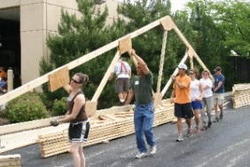 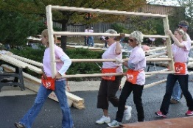 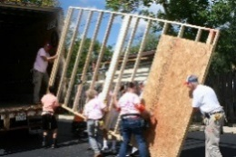

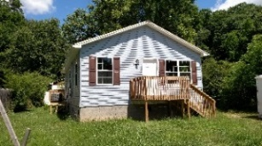

**Questions?   Please contact Paula Mack at** [**pmack@connect2amc.com**](mailto:pmack@connect2amc.com) **or 847-375-4791.**

**Solidrockcarpenters.org**