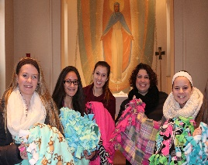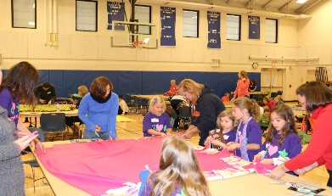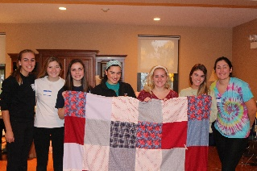 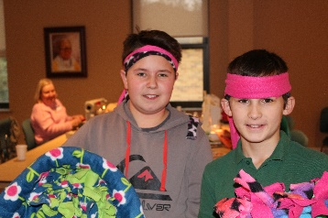
MSW CCW 16th Annual Blanket of Dreams
Mary Seat of Wisdom
1335 S. Clifton Avenue (Enter at Clark Ministry Center)
Park Ridge, Illinois
November 18, 2017
8:00 a.m. to 6:00 p.m.
Everyone Invited – Families, friends, Scouts, teams - Great Service Opportunity!
Come for an hour or stay all day
No need to know how to sew!
Bring a Pair of Scissors and 4 yards of Fleece for an adult blanket
If you do sew, bring your sewing machine!
Free Refreshments for blanket-makers throughout the day
For more information see: www.blanketofdreams.com

