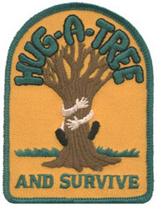

Hug-a-Tree and Survive

Program Presentation

The Park Ridge Community Emergency Response Team (CERT) Search & Rescue Team and Community Outreach Team delivers the Hug-a-Tree and Survive program to teach children how to survive in the woods should they become lost.
Since its inception in 1981 after the search for a 9-year-old California boy ended in tragedy, the Hug-a-Tree program has been presented nationwide to thousands of children and countless lives have been saved as a result.
The Hug-a-Tree and Survive program is offered free of charge and teaches children how to survive in the woods should they become lost. The program was developed primarily for children aged five to twelve and teaches a select few of the most basic and vital survival principles. The presentation lasts 30-40 minutes and includes a short video and other demonstrations aimed at teaching children to tell an adult where they are going, to “hug-a-tree” and stay put if they are lost, how to keep warm and dry in the woods, how to signal for help using a whistle and/or reflector and how to help searchers, on the ground and in the air, find them by making themselves big and by answering their calls.
For more information or to request a Hug-a-Tree and Survive presentation for your school or group, please send inquiry to: parkridgecert@gmail.com

