History Comes Alive with Lynn Rymarz

I always enjoyed learning about history. As a young girl I wanted to be an archaeologist when I grew up, to dig in the past and discover hidden treasures. As an author and storyteller, I am in a sense doing what I dreamed of doing. I enjoy sharing little-known historical stories with readers and audiences. Such stories have been published in children’s magazines. I also share stories through the characters of my programs.

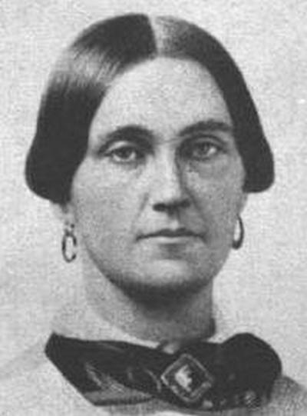 Mary Elizabeth Jenkins Surratt (1820 or May 1823 – July 7, 1865) was an American boarding house owner who was convicted of taking part in the conspiracy to assassinate President Abraham Lincoln. Sentenced to death, she was hanged, becoming the first woman executed by the United States Federal Government.

THE GHOST OF MARY SURRATT
“I should not have died on July 7, 1865 for the conspiracy of killing President Abraham Lincoln,” says the ghost of Mary Surratt. “I was innocent.” Join me as I tell the story of Mary Surratt, convicted and hung as one of Lincoln’s conspirators in his assassination. Hear Mary’s story come alive as she tells of her life as a loving mother, a grieving widow and a landlord. Listen to the events that led up to Lincoln’s assassination, her involvement with John Wilkes Booth and the other conspirators, her arrest, her own testimony and others at the military trial. Hear the words of the verdict, how she proclaimed her innocence in the days she spent before she went to the gallows to be hung as the first woman in the US to be executed. Decide for yourself if Mary Surratt was guilty or innocent of the conspiracy of killing President Abraham Lincoln.
Summit of Uptown
The Ghost of Mary Surratt
Presented by Lynn Rymarz
Thursday, Oct. 31st, 1:30

