

*Live Music on  
 Weekends!*

*Great Fun for the Whole Family!*

**++++** *15th Annual* **++++**

Youth Pumpkin Patch

Proceeds Benefit PRCC Youth Ministry

& the Anthony Rizzo Family Foundation



October 13-31 2018

Monday Closed

Tuesday- Friday 3:30pm – 7:00pm

Saturday 9:00am – 7:00pm   
Sunday 11:00am – 7:00pm

Fridays & Saturdays – Movie at Dusk

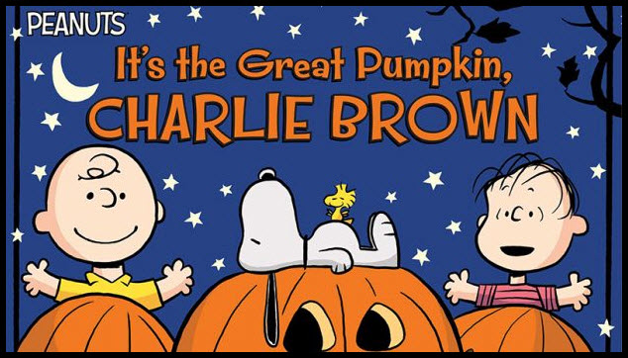

Free Showing - October 13, 19, 20, 26, 27

*Weather Permitting*

*Pumpkin Patch is located just south of the Church–*

*at the corner of Prospect & Crescent Avenues.*

*Seasonal Items & Baked Goods*

*Pumpkins – All Shapes & Sizes*

For further info: [www.parkridgecommunitychurch.org](http://www.parkridgecommunitychurch.org)

Park Ridge Community Church 100 S. Courtland Ave., 60068

